**The measurements Fragment**

The communication between the hardware kit, the server and the mobile application is one of the main focus points of this project and no fragment in the application capitalize on that connection as the measurements fragment.

The fragment is designed to display the latest measurements their status in a table, also keeps history of the old ones and can display them if needed but the most important function that goes beyond the fragment it’s self is the background operation that receives the measurement and take action based on the status such as calling the doctor or sending him a message or even call for an ambulance if the case is very serious. a UML class diagram for the fragment is shown in figure (x).

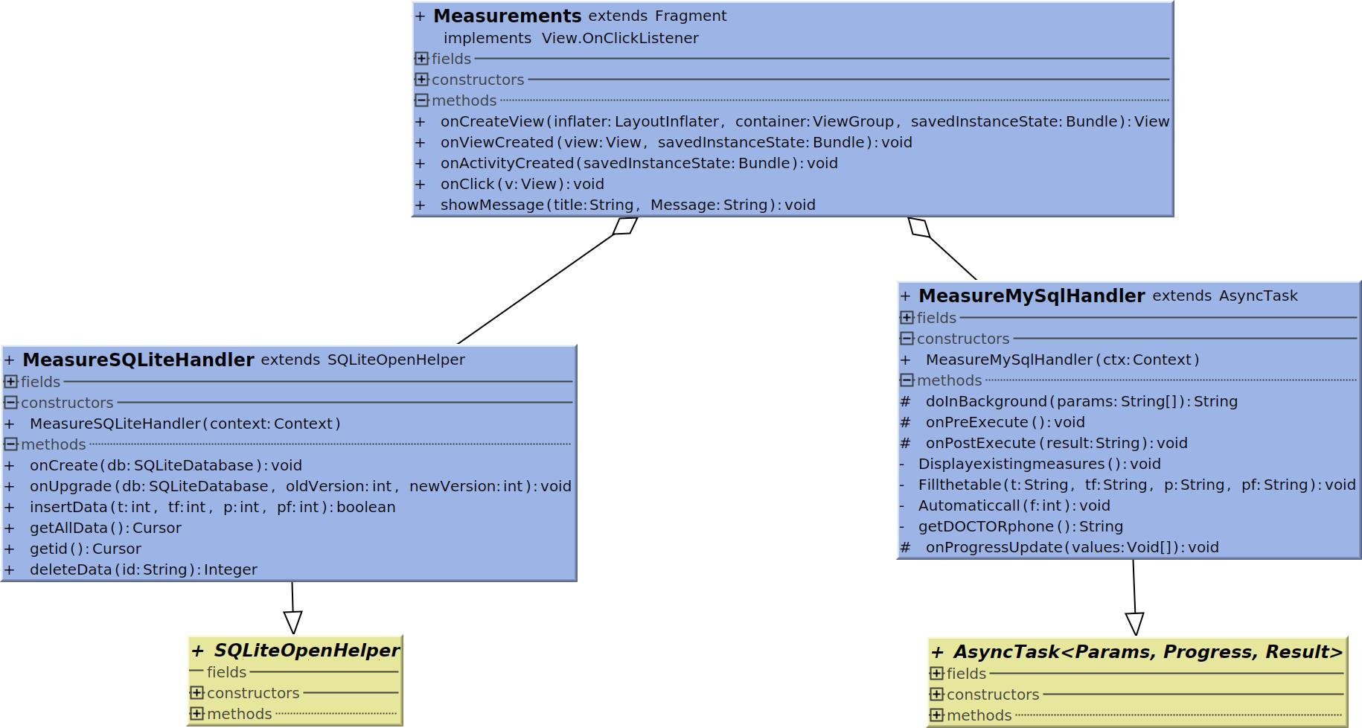

Figure x: Class diagram for measurements.

MeasureMysqlHandler is the class that handle most of the functionality in the background and also deal with placing the data on the table. Displayexistingmeasures and Fillthetable are the two functions displaying the data for the user to view them if needed.

MeasureMysqlHandler inherits AsyncTask to create a thread to handle the networking operation smoothly without putting on hold all other functions. The function of receiving the patient measurements and take actions is very important so it runs in the application background always not only in the fragment background. doInBackground establishes a connection with the webserver to send the user unique name and receive only the new measurements by comparing the data of the newest measure received on the application. the response received wich contains the new measurements is passed to onPostExecute to be stored, displayed if the app on the right fragment and take actions such as calling or messaging the doctor, a family member or even an ambulance if needed.

MeasureSQLiteHandler is a subclass to SQLiteOpenHelper responsible for creating a database table to insert, update, view or delete data from. The measurements table is shown in in table y

Table y: Measurements_Table

|  |
| --- |
| Measurements_Table |

|  |  |
| --- | --- |
| ID | IINTEGER PRIMARY KEY AUTOINCREMENT |
| TEMPERATURE | INTEGER |
| TEMPERATUE FLAG | INTEGER |
| HEARTRATE | INTEGER |
| HEARTRATEFLAG | INTEGER |

The temperature and heart rate flags are integers used to indicate how dangerous the measure is and for how long it has been in this state, the larger the number is the more serious the case is.

There are only fields for the sensors in the hardware prototype kit but the more the hardware can provide the better for the patient it could be.

Measurements class extend Fragment class and is responsible for inflating the layout and using the classes running the background networking operations to do the required functions. Figure x+1 shows the GUI this fragment provides.

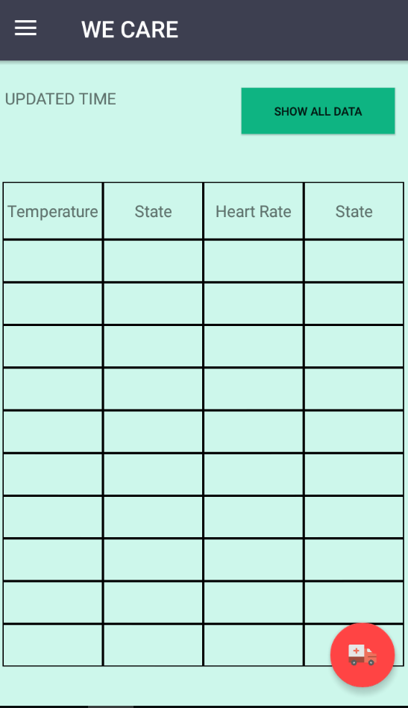

Figure x+1: GUI for measurements fragment

The Lay out provides a table to display the latest 10 received measures and shows the time for the latest received data. Show all data button provide a list of all the measures received and stored in the mobile database. Another feature that isn’t finished is to provide a graph that plots the measurements with time to give an indication of the case in certain time periods.

The functions this fragment provides are shown in figure x+3 to summarize its operation

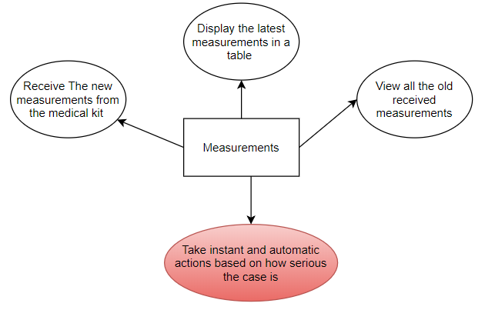

Figure x+3